December 08, 2020

Team Members:

Irwin Singh (Team Leader)

Danish Habib

**Project Goal**

The goal of our project is to build a web-based learning management system that provides an

online course learning and tutoring service for students ranging from Kindergarten to Grade 12 in different subjects.**project objectives**

The main players involved in this project are regular users who can visit our website and look for courses they are interested in, and signed in users. The main objective of the project is to provide services to both players involved according to their needs and requirements.

The users can browse through the list of courses and can choose which course they are interested in.

There will be 3 kinds of signed in users.

* Administrators will have access to all the records of students , instructors and courses. They can also create and delete courses.
* Instructors once assigned a course by the administrator can create assignments for that course and mark the assignments submitted by the student.
* Students can enroll in a course once they are signed in they can view assignments and submit answers to the assignments.

The sign in feature will be implemented and give access to the features according to users roles. In terraform minds database

Role = 1 is Administrator

Role = 2 is Instructor

Role = 3 is Student

Keeping the separation of roles is very important in our project.

### 

### 

### Project scope

The scope of our project is to include following main pages in our website

**Users**:

Users visiting the site are able to view a full list of available courses which are categorized by grade bracket (K-12) and subject (Math, Science, English, Social Studies). Users are able to filter by grade bracket and/or subject to narrow down the available courses. If a user would like to enroll in a course, they are able to create an account, login and register. Users are limited to browsing through the list of courses and viewing their description.

**Main Features/Screens**:

* Home Page
* List of Courses
* Course detail
* Sign In (for already registered user)
* Register new user
* About

**Student**:

Once registered and accepted into a course the user is now a student and has the ability to view that specific course’s Assignments.

**Main Features/Screens:**

* Student Dashboard:
* Courses List,
* Course Details
* Assignments,
* Attempt Assignment.

**Instructors**:

Instructors will be able to login. Instructors will be able to add assignments and mark assignments.

**Main Features/Screens:**

* Instructor Dashboard
* Course List,
* Course Details
* Create Assignments
* View assignments submitted by student
* Mark students' assignments.

**Admin**:

Admin are able to login, add/update/delete courses and assign courses to an instructor.

**Main Features/Screens**:

* Admin Dashboard
* Instructor List
* Instructor details and courses assigned to them
* Students List
* Student details and courses they are enrolled in
* Course List
* Edit course
* Delete course
* Create course

The stack we are going to use to implement these features is

.NET Core Web MVC, ASP.NET ,Entity Framework , MySQL, JavaScript , Bootstrap

**Project schedule**

To keep the project on track we are going to use Google sheets the link to them can be found here <https://docs.google.com/spreadsheets/d/1WaS1G5FNC8cGz5UKtgL76OJpWIGfY3pj/edit?rtpof=true#gid=787204301>

and it is also available in our project plan document.

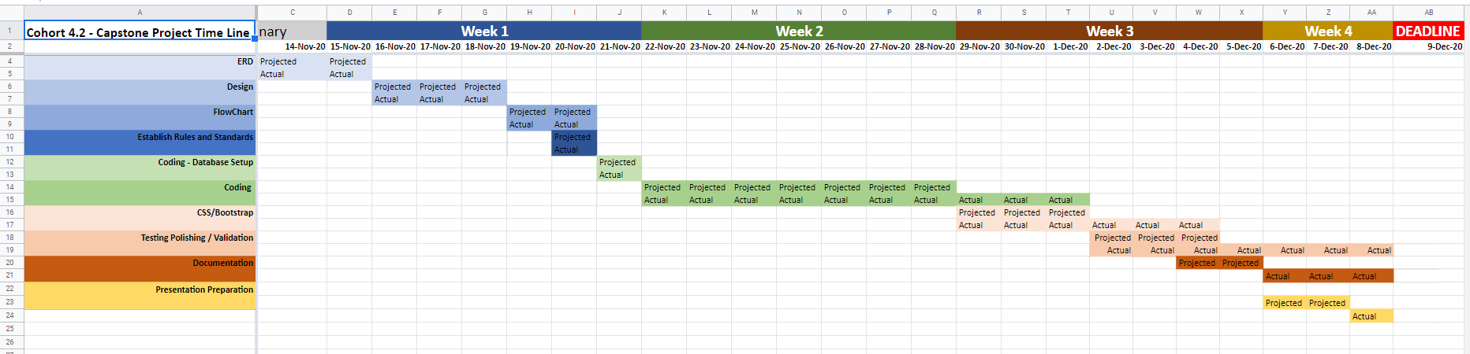

**Initial Planning Documentation**

The initial phase of our project required a detailed ERD and workflow document .

The ERD went through many iterations before it reached to its polished shape

<https://app.diagrams.net/#G1FIHy9OpJg1aDy5MAkD8S23x-qGcrhSQq>

and also available in our project plan folder

ERD initial look

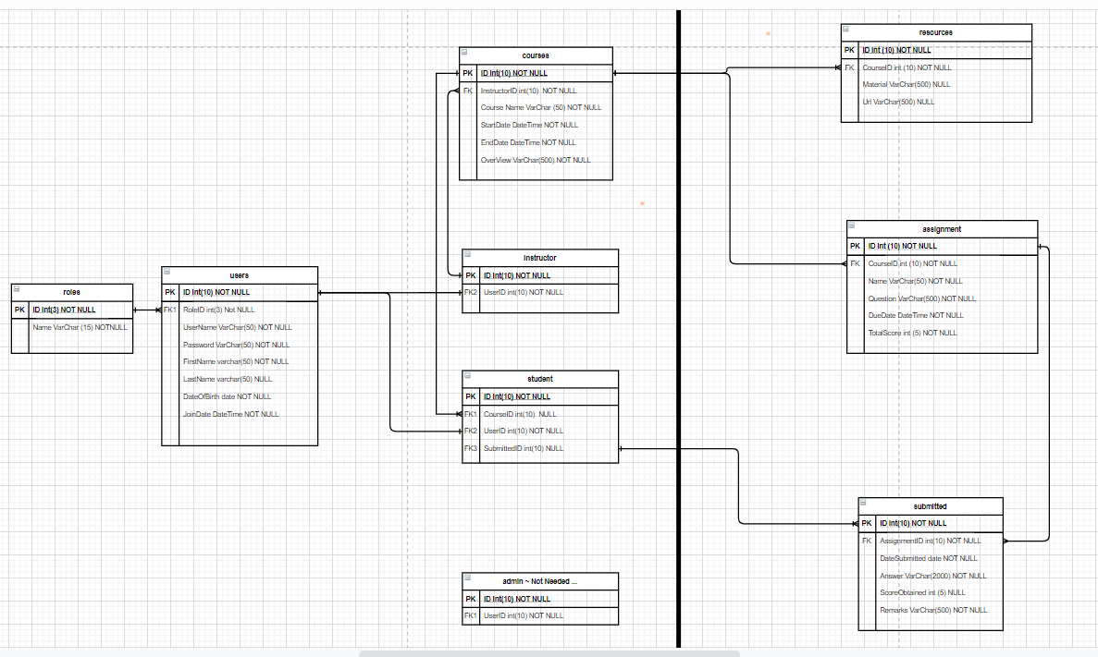

Final Implemented ERD

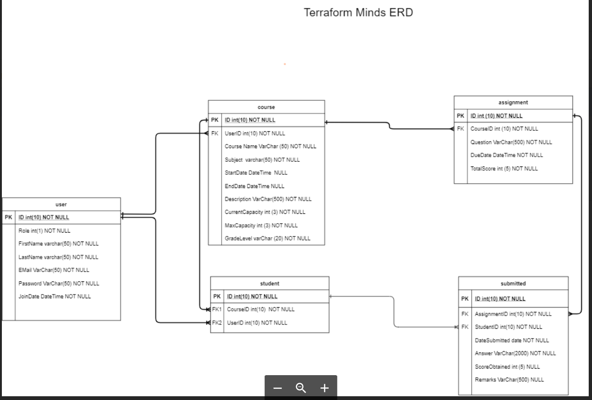

**Design and Layout:**

To design the outlook of our project we used figma. The project went through many iterations before it reached its final state. the design process can be found in our figma page

<https://www.figma.com/file/QnoWoVyyAzGXVYcdtTxRI8/Dream-%26-Imagine?node-id=239%3A41>

Some of the key highlights of this process are the following.

During the first design implementation for our LMS website. We came up with core concepts that our application is going to have.

Core concepts:

* Courses
* Administrator Dashboard
* Instructor Dashboard
* Student Dashboard
* Sign and user registration

**Courses Section**

Throughout the application, if you were a visitor, user, student, the individual would have the option to view a list of all available courses. The purpose of the course list was to show detailed course information that includes teacher, course name, course description, start/end Dates, and course capacity.

For styling we wanted to have the courses displayed in a card format. 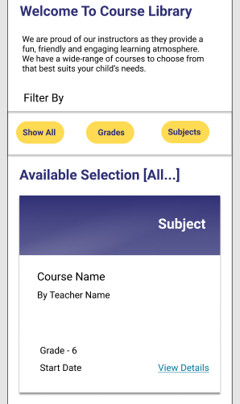

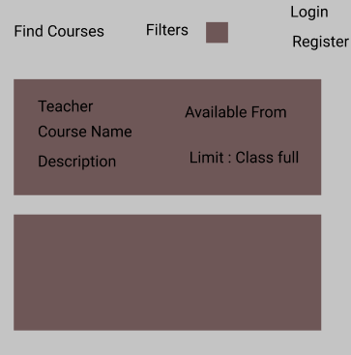

Initial Design Final Design

**Administrator Dashboard**

An important role for the application was that of the administrator. Like any administrator, they had the power to create/edit/delete courses, instructors, students. The role of the instructor is important as they were the only ones to have power in controlling the database.

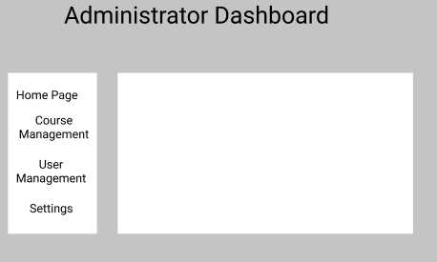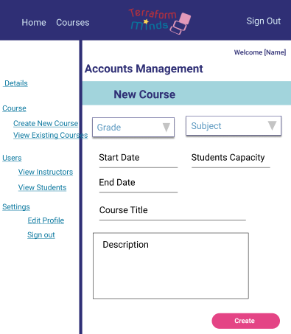

Initial Design Final Design

**Instructor Dashboard & Student Dashboard**

The instructor and student dashboard are very similar with only minor differences.

The instructor dashboard was tied to the resource and assignment table where the teacher would be able to add resource information and URLs as well as set assignments.

The student dashboard allowed the student to view the courses they were enrolled in and view any course resources, assignments and submit their assignments.

The final design looks more-or-less like the initial concept but with CSS bootstrap styling that has a similar layout to the administrator Hi-Fi design.

**Instructor Dashboard - Initial Concept**:

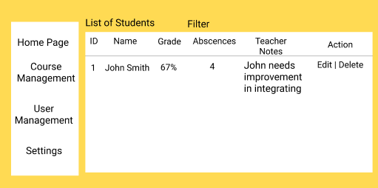

**Student Dashboard - Initial Concept**:

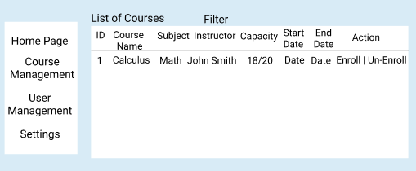

In addition to our core concepts, for our homepage, we wanted it to have simple with friendly colours and images because our application caters towards a kindergarten to grade 12 audience.

For our homepage layout we drew inspiration from other LMS websites such as Kiddom.com.

**Home Page - Initial concept**:

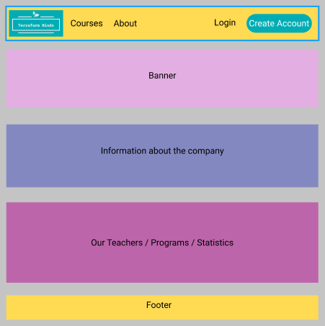

**Home Page – HiFi Design**:

*Please note that the following images are broken into 3 pieces in order to show the details of the home page.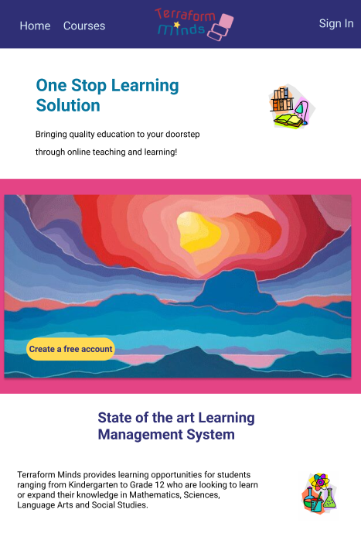

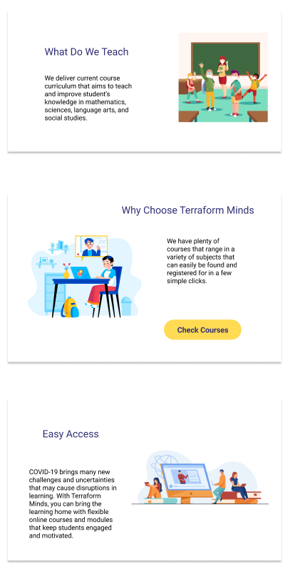

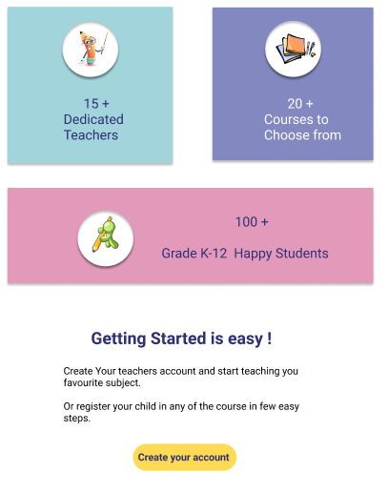

**Validations:**

Throughout our application we needed to maintain some key validation points. These are as follows.

* All inputs are trimmed and non null fields are checked before inserting or updating in database
* Email is validated using regex
* Password is hashed and then entered in database
* Email needs to be unique for every registered user
* Integer and date fields are checked before inserting in database
* Have validation at both client and server side
* Records exist after the user has logged out, cleared their browser cache, and returned to the application.
* The record is deleted properly and child records are not left orphan
* If a course is in progress the administrator won't be able to delete it.
* When the administrator creates a new course the course end date cannot be set prior to today though they have the option to keep start and end dates null, and add them later.
* Instructors won't be able to set the due date for assignment prior to current day or after the end of course.
* Instructors can have the maximum and minimum score for assignment between 0 and 100.
* Once the maximum score for an assignment is set the assignment is graded between 0 and that score.

These validation points are demonstrated in more detail in our test plan document.

**Stretch goals**:

Our initial project proposal included some more features and stretch goals. Due to time constraints we needed to prioritize our tasks and moved a few more features in stretch goals.

The stretch goals for our project include :

* Resource Page for student and instructor
* Grading system to assess the students based on their assignment and quiz scores
* Messaging service between students and instructor
* Class Schedule on Calendar
* Instructors Rating
* Upload image/pdf feature on assignment page
* Quizzes created by instructors and sent to students to complete

**Citations**:

During the lifetime of this project we consulted many online resources. Their list is as follows.

**Password Hash and Salt**

<https://docs.microsoft.com/en-us/aspnet/core/security/anti-request-forgery?view=aspnetcore-5.0>

<https://crackstation.net/hashing-security.htm>

<https://auth0.com/blog/adding-salt-to-hashing-a-better-way-to-store-passwords/>

**For Client Side input fields Validation:**

<https://www.blinkingcaret.com/2016/03/23/manually-use-mvc-client-side-validation/>

**Regex Expression:**

<https://regexr.com/3e48o>

**Login Authentication :**

<https://www.c-sharpcorner.com/article/authentication-and-authorization-in-asp-net-core-mvc-using-cookie/>

<https://docs.microsoft.com/en-us/aspnet/core/security/authorization/roles?view=aspnetcore-5.0>

<https://docs.microsoft.com/en-us/aspnet/core/security/authentication/cookie?view=aspnetcore-2.2#create-an-authentication-cookie-1>

**Match Email regex :**

<https://www.dotnetperls.com/regex>

**Bootstrap:**

<https://mdbootstrap.com/docs/jquery/navigation/navbar/>

<https://getbootstrap.com/docs/5.0/getting-started/introduction/>

**Button style:**

<https://bootstrapbay.com/blog/bootstrap-button-styles/>

**Side bar:**

<https://www.codeply.com/go/Rgq96HykJ2/sidebar-that-changes-to-navbar>

**Photo Collage Course Page:**

<https://pixabay.com/photos/art-chalk-child-childhood-color-3509511/>

<https://pixabay.com/photos/colour-color-colorful-pencil-316776/>

<https://unsplash.com/photos/IOzk8YKDhYg>

**Photo Collage Home page inspired by:**

<https://tedharrison.ca/>

**WebAIM contrast checker:**

<https://webaim.org/resources/contrastchecker/>

**Images compressed using:**

<https://tinypng.com/>

**CSS W3C validator:**

<https://jigsaw.w3.org/css-validator/>

**Wireframes done using:**

https://www.figma.com/

**ERD Drawn using**: Drawio

**Time Tracking in** : Google sheets